**Practical No:-1**

**Aim :- Implement the following CPU scheduling algorithm.**

1. **:FCFS (First Come First Serve)**
2. **SJF (Preemptive and Non Preemptive)**

**Name : Anas Ahmad Ilyas Ahmad Subject:OS Batch : 1**

**Class : MCA-Sem I Roll No: 222010001 Date:-12/12/2022**

1. **FCFS(First Come First Serve):**

**Source code:**

#include <bits/stdc++.h>

using namespace std;

class Process{

public:

int p_id;

int arrival_time;

int burst_time;

int start_time; // first time cpu allotment time

int completion_time;

int turnaround_time;

int waiting_time;

int response_time;

};

bool compareArrivalTime(Process p1, Process p2){

if (p1.arrival_time < p2.arrival_time){

return true;

}else{

return false;

}

}

bool compareID(Process p1, Process p2){

if (p1.p_id < p2.p_id) {

return true;

}else{

return false;

}

}

int main(){

int n;

cout << "Enter number of processes:";

cin >> n;

Process p[n];

int total_turnaround_time = 0;

int total_waiting_time = 0;

int total_response_time = 0;

for (int i = 0; i < n; i++){

cout << "Enter arrival time of process " << i + 1 << ": ";

cin >> p[i].arrival_time;

cout << "Enter burst time of process " << i + 1 << ": ";

cin >> p[i].burst_time;

p[i].p_id = i + 1;

cout << endl;

}

sort(p, p + n, compareArrivalTime);

for (int i = 0; i < n; i++){

if (i == 0){

p[i].start_time = p[i].arrival_time;

}else{

p[i].start_time = max(p[i - 1].completion_time, p[i].arrival_time);

}

p[i].completion_time = p[i].start_time + p[i].burst_time;

p[i].turnaround_time = p[i].completion_time - p[i].arrival_time;

p[i].waiting_time = p[i].turnaround_time - p[i].burst_time;

p[i].response_time = p[i].start_time - p[i].arrival_time;

total_turnaround_time = total_turnaround_time + p[i].turnaround_time;

total_waiting_time = total_waiting_time + p[i].waiting_time;

total_response_time = total_response_time + p[i].response_time;

}

sort(p, p + n, compareID);

cout << "#P\t"<< "AT\t"<< "BT\t"<< "ST\t"<< "CT\t"<< "TAT\t"<< "WT\t"<< "RT\t"<< "\n"<< endl;

for (int i = 0; i < n; i++){

cout << p[i].p_id << "\t" << p[i].arrival_time << "\t" << p[i].burst_time << "\t" << p[i].start_time << "\t" << p[i].completion_time << "\t" << p[i].turnaround_time << "\t" << p[i].waiting_time << "\t" << p[i].response_time << "\t"<< "\n"<<endl;

}

cout << "Average Turnaround Time: " << (float)total_turnaround_time / n << endl;

cout << "Average Waiting Time: " << (float)total_waiting_time / n << endl;

cout << "Average Response Time: " << (float)total_response_time / n << endl;

return 0;

}

**Output:**

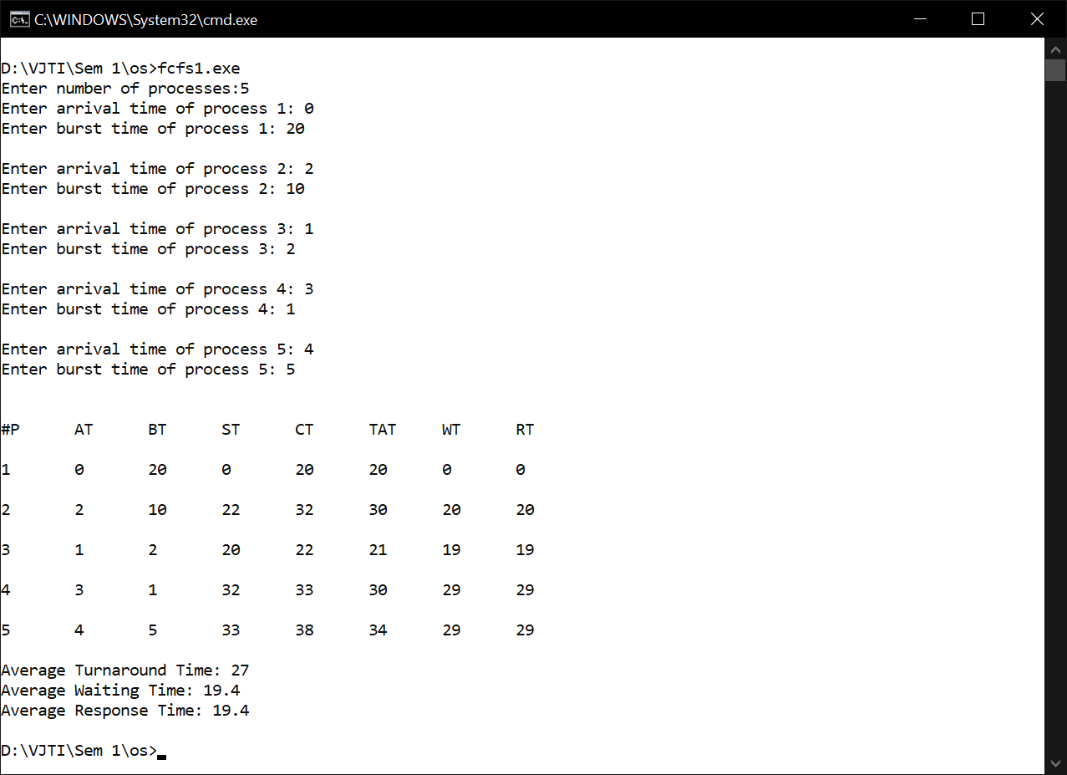

1. **i) SJF (Shortest Job First) Non Pre-emptive:-**

**Source Code:**

#include <bits/stdc++.h>

using namespace std;

class Process{

public:

int p_id;

int arrival_time;

int burst_time;

int start_time; // first time cpu alloted time

int completion_time;

int turnaround_time;

int waiting_time;

int response_time;

};

int main(){

int n;

cout << "Enter number of processes:";

cin >> n;

Process p[n];

bool is_completed[n] = {false};

int total_turnaround_time = 0;

int total_waiting_time = 0;

int total_response_time = 0;

for (int i = 0; i < n; i++){

cout << "Enter arrival time of process " << i + 1 << ": ";

cin >> p[i].arrival_time;

cout << "Enter burst time of process " << i + 1 << ": ";

cin >> p[i].burst_time;

p[i].p_id = i + 1;

cout << endl;

}

int current_time = 0;

int completed = 0;

while (completed != n){

int curr_process = -1;

int minimum_burst_time = INT_MAX;

for (int i = 0; i < n; i++){

if (p[i].arrival_time <= current_time && is_completed[i] == false){

if (p[i].burst_time < minimum_burst_time){

minimum_burst_time = p[i].burst_time;

curr_process = i;

}

if (p[i].burst_time == minimum_burst_time){

if (p[i].arrival_time < p[curr_process].arrival_time){

minimum_burst_time = p[i].burst_time;

curr_process = i;

}

}

}

}

if (curr_process != -1){

p[curr_process].start_time = current_time;

p[curr_process].completion_time = p[curr_process].start_time + p[curr_process].burst_time;

p[curr_process].turnaround_time = p[curr_process].completion_time - p[curr_process].arrival_time;

p[curr_process].waiting_time = p[curr_process].turnaround_time - p[curr_process].burst_time;

p[curr_process].response_time = p[curr_process].start_time - p[curr_process].arrival_time;

total_turnaround_time = total_turnaround_time + p[curr_process].turnaround_time;

total_waiting_time = total_waiting_time + p[curr_process].waiting_time;

total_response_time = total_response_time + p[curr_process].response_time;

completed++;

is_completed[curr_process] = true;

current_time = p[curr_process].completion_time;

}else{

current_time++;

}

}

cout << "#P\t"<<"AT\t"<<"BT\t"<<"ST\t"<<"CT\t"<<"TAT\t"<<"WT\t"<<"RT\t"<<"\n"<<endl;

for (int i = 0; i < n; i++){

cout << p[i].p_id << "\t" << p[i].arrival_time << "\t" << p[i].burst_time << "\t" << p[i].start_time << "\t" << p[i].completion_time << "\t" << p[i].turnaround_time << "\t" << p[i].waiting_time << "\t" << p[i].response_time << "\t"<< "\n" << endl;

}

cout << "Average Turnaround Time: " << (float)total_turnaround_time / n << endl;

cout << "Average Waiting Time: " << (float)total_waiting_time / n << endl;

cout << "Average Response Time: " << (float)total_response_time / n << endl;

return 0;

}

**Output:**

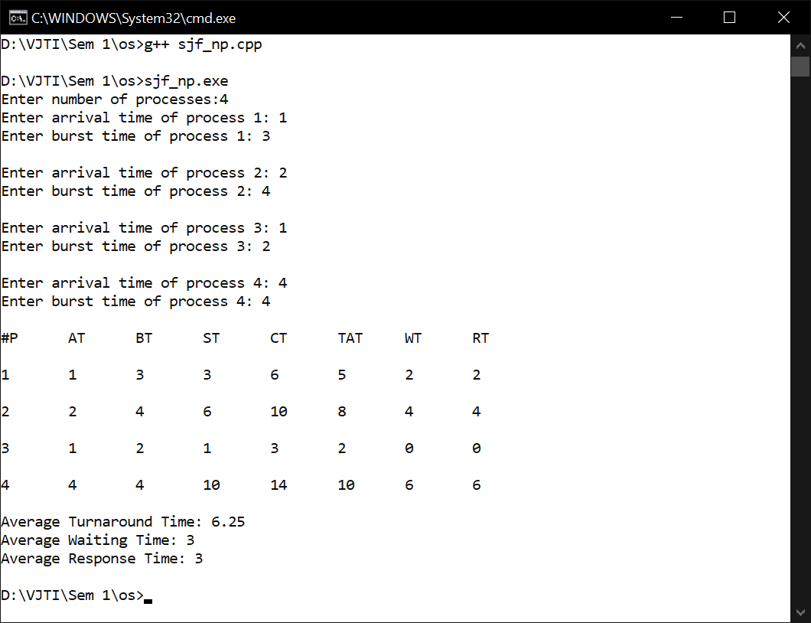

1. **ii) SJF (Shortest Job First) Pre-emptive or SRTF:-**

**Source Code:**

#include <bits/stdc++.h>

using namespace std;

class Process{

public:

int p_id;

int arrival_time;

int burst_time;

int remaining_burst_time;

int start_time; // first time cpu alloted time

int completion_time;

int turnaround_time;

int waiting_time;

int response_time;

};

int main(){

int n;

cout << "Enter number of processes:";

cin >> n;

Process p[n];

bool is_completed[n] = {false};

bool is_in_queue[n] = {false};

int total_turnaround_time = 0;

int total_waiting_time = 0;

int total_response_time = 0;

for (int i = 0; i < n; i++) {

cout << "Enter arrival time of process " << i + 1 << ": ";

cin >> p[i].arrival_time;

cout << "Enter burst time of process " << i + 1 << ": ";

cin >> p[i].burst_time;

p[i].remaining_burst_time = p[i].burst_time;

p[i].p_id = i + 1;

cout << endl;

}

int completed = 0;

int current_time = 0;

while (completed != n) {

int curr_process = -1;

int minimum_burst_time = INT_MAX;

for (int i = 0; i < n; i++){

if (p[i].arrival_time <= current_time && is_completed[i] = false){

if (p[i].remaining_burst_time < minimum_burst_time){

minimum_burst_time = p[i].remaining_burst_time;

curr_process = i;

}

if (p[i].remaining_burst_time == minimum_burst_time){

if (p[i].arrival_time < p[curr_process].arrival_time){

minimum_burst_time = p[i].remaining_burst_time;

curr_process = i;

}

}

}

}

if (curr_process != -1){

if(p[curr_process].remaining_burst_time == p[curr_process].burst_time){

p[curr_process].start_time = current_time;

}

p[curr_process].remaining_burst_time--;

current_time++;

if(p[curr_process].remaining_burst_time == 0){

p[curr_process].completion_time = current_time;

p[curr_process].turnaround_time = p[curr_process].completion_time - p[curr_process].arrival_time;

p[curr_process].waiting_time = p[curr_process].turnaround_time - p[curr_process].burst_time;

p[curr_process].response_time = p[curr_process].start_time - p[curr_process].arrival_time;

total_turnaround_time = total_turnaround_time + p[curr_process].turnaround_time;

total_waiting_time = total_waiting_time + p[curr_process].waiting_time;

total_response_time=total_response_time + p[curr_process].response_time;

is_completed[curr_process]=true;

completed++;

}

}

else{

current_time++;

}

}

cout << "#P\t"<< "AT\t" << "BT\t"<< "ST\t"<< "CT\t"<< "TAT\t"<< "WT\t"<< "RT\t"<< "\n"<< endl;

for (int i = 0; i < n; i++){

cout << p[i].p_id << "\t" << p[i].arrival_time << "\t" << p[i].burst_time << "\t" << p[i].start_time << "\t" << p[i].completion_time << "\t" << p[i].turnaround_time << "\t" << p[i].waiting_time << "\t" << p[i].response_time << "\t" << "\n"<< endl;

}

cout << "Average Turnaround Time: " << (float)total_turnaround_time / n << endl;

cout << "Average Waiting Time: " << (float)total_waiting_time / n << endl;

cout << "Average Response Time: " << (float)total_response_time / n << endl;

return 0;

}

**Output:**

